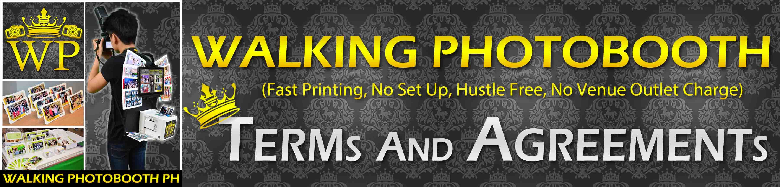

**IMPORTANT PLEASE READ:**

\***EXTRA TRANSPORT CHARGE** may Apply (**If the Venue is Outside our Coverage Area**).

* For first time Client we require a Deposit of 50% on our bank account to reserve the booking date and in order for us to start making the Layout Design.

* Full Payment / Remaining Balance is Right after the Event (Cash Payment Only)

(If our Client Didn’t Pay the remaining Balance after the event, we may Sue them in court and they will pay double the amount of our Service Fee. (**READ THIS PLEASE**)

* Layout Design labor is free and fully customizable with your desired design you may send picture, logo, invitation, we’ll send an email for confirmation and revisions. **(We will submit the layout design, at least 1week of before the event).**

* **Clients Must Provide the Exact Information of the Time and Date of the Event**.

-Please do take note that if the client provided advance event time or the event is delayed, we will charge additional payment for the waiting time 500php per hour of waiting. Because we go almost 1 hour early before the event to avoid being late.

*Our client must provide a place where the photographers can leave their bags safe.

*We will charge additional 1’500php per 1Hour if the client exceeded their time of service, for 30minute extension 800php. (If the client wants to extend)

* **Client must provide at least Crew Meals for our Photographer and Assistant** or food budget of 150php each person (300php) before or after the service is done and failure to provide this, we’ll charge additional 500php for each person. (1’000 total)  
  
 We do not give any kind of REFUND (Please Take Note on This)

Customers Name and Signature: ____________________

(By signing this you agree to our terms and conditions, Thank You!)

**Here is our Official Bank Account for Booking Down payments:**



**PLEASE READ:**

*Our TIN Number Account name is under Eric Bruce P. Lozano

*We Prefer on our BDO Account. (This is for Cash Deposit payment only)

*We have a Minimum Down payment of 1’500php for returning client and 50% Downpayment for New Clients in order for us to reserve the event booking date.

*Downpayment is not refundable if you cancel your Booking.   
(If our client is fully paid, only 70% will be refundable).

*Please do send us the Receipt after making the down payment for us to review.  
(Please do take a picture of the receipt and send or reply it to us via Email).

**inquire.walkingphotobooth@gmail.com**

**Thank You for Choosing our Photobooth / Photography / Videography Services!**

**ADDITIONAL FEE FOR TRANSPORTATION BELOW:**

(CENTER OF MANILA IS FREE OF CHARGE FOR TRANSPORTATION)

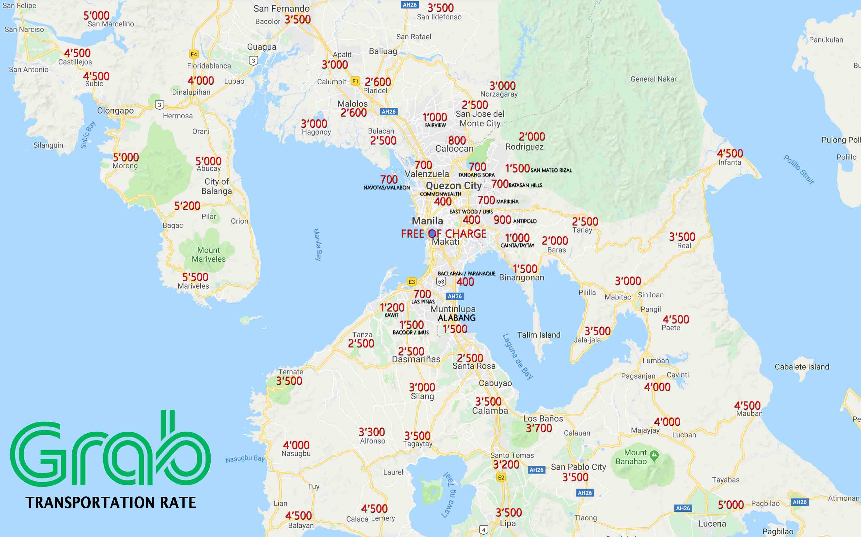

**PLEASE TAKE NOTE THAT SOME PARTS OF METRO MANILA REQUIRES ADDITIONAL TRANSPORTATION FEE:**

(Kindly please check our Transportation Charges Above)

for more Information Regarding on Charges Kindly please email us,  
  
Thank You ☺!

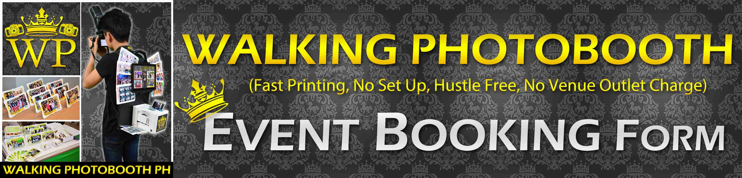

**(YOU MAY JUST EDIT THE DOCUMENT BELOW NO NEED TO PRINT)**

Event Title**: (Name of the Event that will be on the Layout Design)**

Event Date: (Date of the Event)

Contact Persons: (Contact for the Event and their alternative Mobile Numbers)

Event Place: (Full Event Address with Landmark if possible)

Event Start Time/Service Start: (Actual Time of the Event & Service Start Time)

Number of Guest: (Estimated Number of the Guest)

Number of Hours and Service Rate: (Input Here the Service Hours & Rate)

INSTRUCTIONS or NOTE: (Input here any Instructions for our team)

(**RUSHED LAYOUT DESIGN** will be Charged **500-PHP** for urgent making)

*Layout Designs will be sent 1week before the event thru Email.

\***Kindly send some Layout, Picture, Invitation, Logo, or Theme Event**.

*Full Payment/ Remaining Balance is right after the Event, **(Cash Only)**

**WALKING PHOTOBOOTH CONTACT DETAILS:**

**TM # 0935-1363-233** (We prefer this number)

**Landline # NOT AVAILABLE**

[inquire.walkingphotobooth@gmail.com](mailto:inquire.walkingphotobooth@gmail.com) & <http://walkingphotobooth.wix.com/inquire>

[www.facebook.com/WalkingPhotoboothPH](http://www.facebook.com/WalkingPhotoboothPH)

DISCOUNTS and Other Charges!

If **Official Receipt** is Required, we can’t Give DISCOUNT as Our Rate is Stated on our Permits

**Additional Charge:**

Rush Layout Design – 500php (will receive the designs within the Day, 2-6hours)

Removal of Walking Photobooth Watermark on Layout Design, Additional Charge - 300php

-If Clients wants to Change our Watermark into other Company Name & Contact - 800php

Additional Layout Design Option, Additional Charge 100php per Design (Free first 2 Designs)

- Free 2 Design to Choose if you want more Design Options, we must charge for additional

Additional Charge for No Food, Time Extensions and Out of Coverage Area’s may Apply

Additional Charge for Magnetic Frames 4R Size (100pcs minimum) 15php each 1’500php

Additional Charge for All Black Layout Design – Additional 500php

-we Charge extra for this because all black color will drain fast our inks and its expensive

**DISCOUNT:**

Layout Design Made by Client, 100php Discount

No Free USB 16GB USB, 100php Discount

Booking of 3 or more Walking Photobooth Units will get less 300php per Unit

Booking of 3 Events or more within 1-3 months’ time will get less 300php per Booking

Booking of 5 Events or more in a Single Booking (get 500php OFF per Event Booking)

Advance Down Payment (3 Months Prior the Event, 200php Discount)

Advance Full Payment (Original Rate Only must have No Other Discount, 300php Discount)