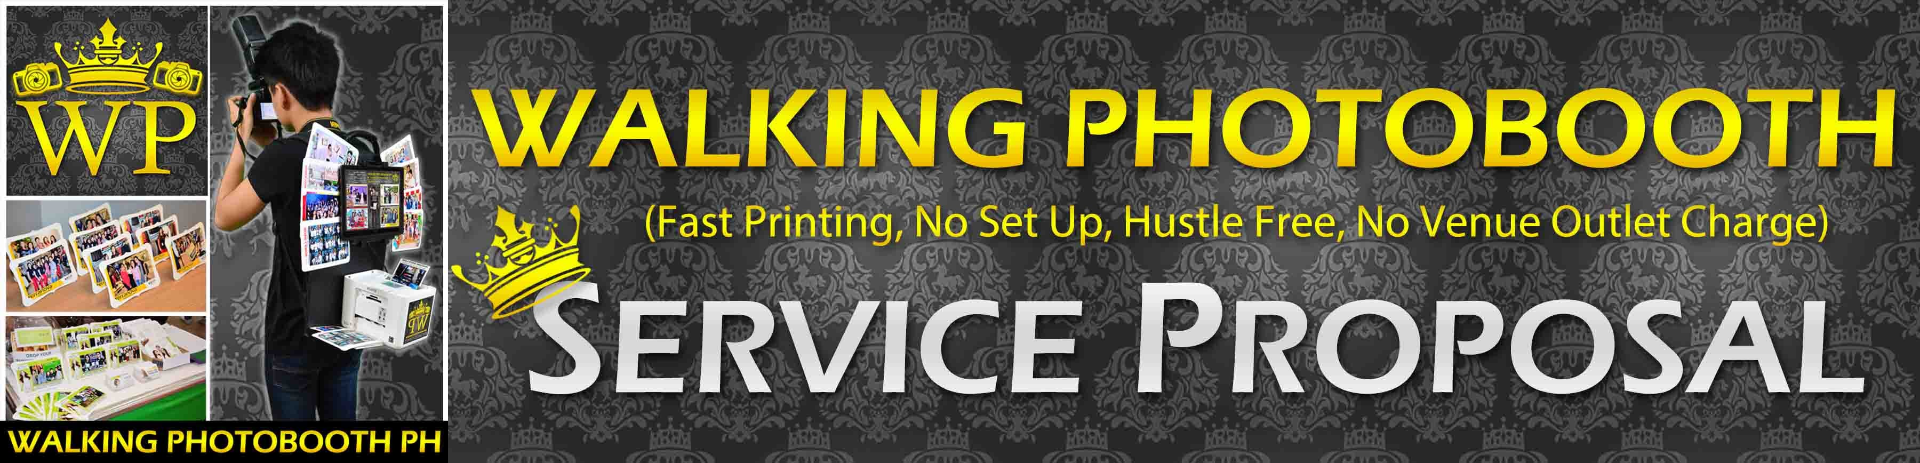

<http://walkingphotobooth.wix.com/inquire> (This is Our Official Website please view)

Walking Photobooth is a mobile photo booth that combines the standard photo booth setup and a Professional Photographer All in One! we can roam the venue and give souvenir pictures anywhere in the events place for just seconds! we can print from 30-45 seconds per photo. (We also take unlimited Coverage Photos while Printing)

You get more for less, meaning we have high quality equipment and service that will amaze your guest in a very affordable price. We can print up to 60-100 pictures per hour for the guest to have many souvenirs. We use only Genuine High-Quality Inks and Papers in order for the pictures to last several years. We have two persons operating the Photoman unit; our team consist of one Photographer and one Technical Assistant they’re both roaming at the event to give souvenir pictures.

**OUR EQUIPMENT’S**

Lenovo Touchscreen Laptop/Tablet (High Quality Display and Interactive viewing of pictures)

Epson 2018 Printer (The New 2018 Printer from Epson that Provides High Quality Printing)

372 Epson High Quality Inks and Photo Papers. (**PRODUCTS ARE ORIGINAL FROM EPSON**)

Nikon D7200 or D500 PRO level DSLR 24.1 Megapixel with External Flash for Quality Pictures

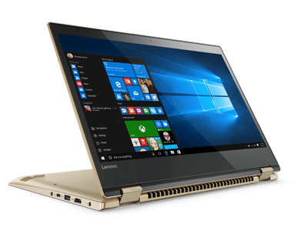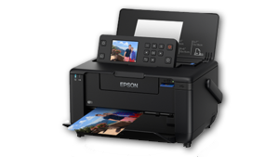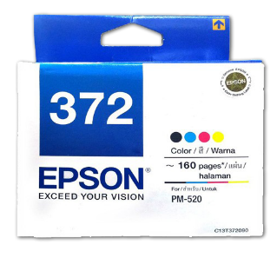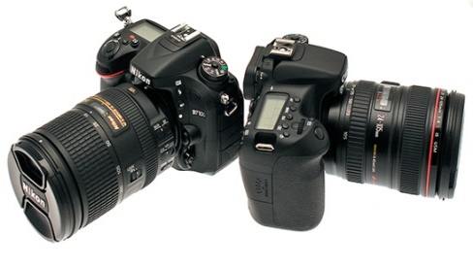

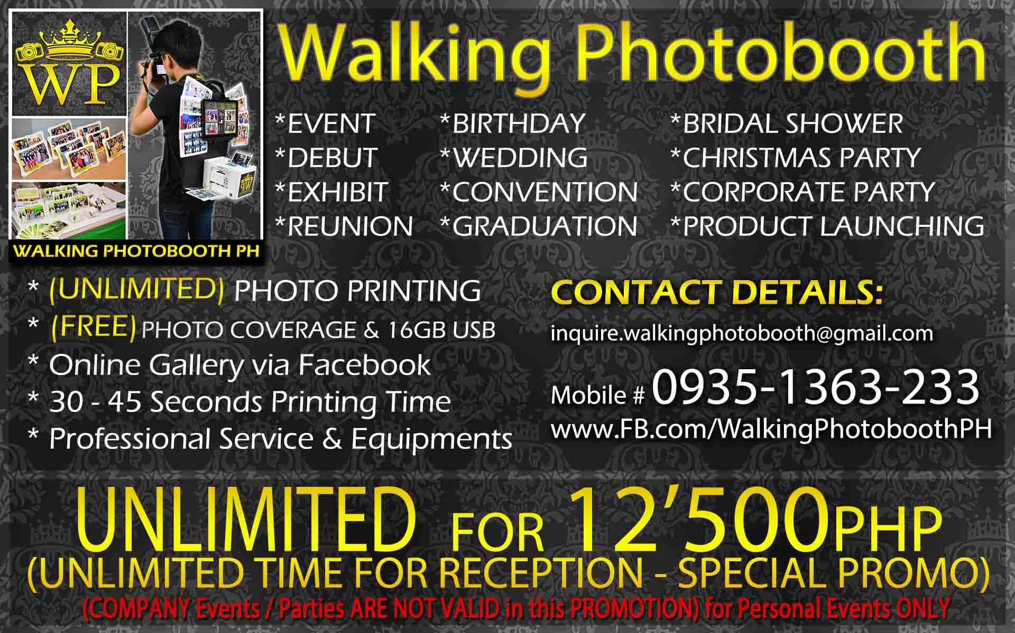

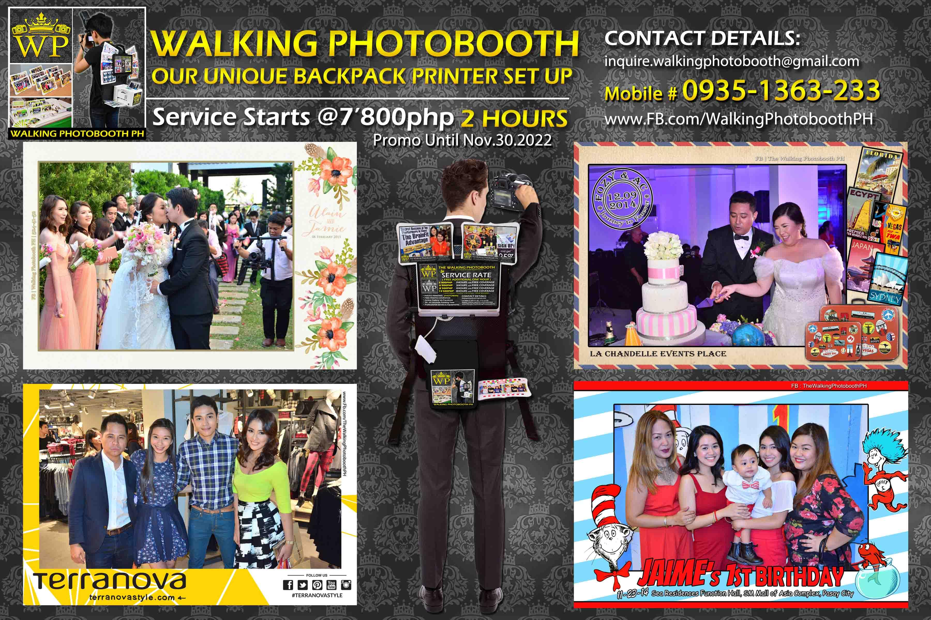

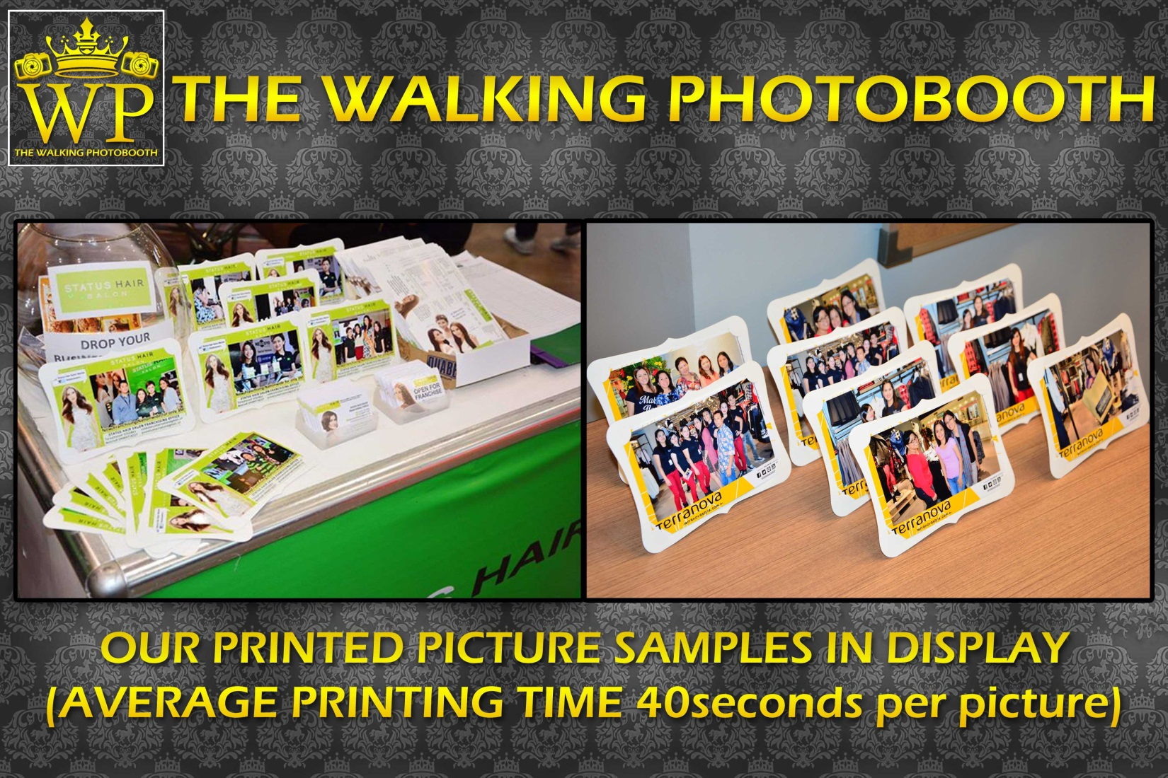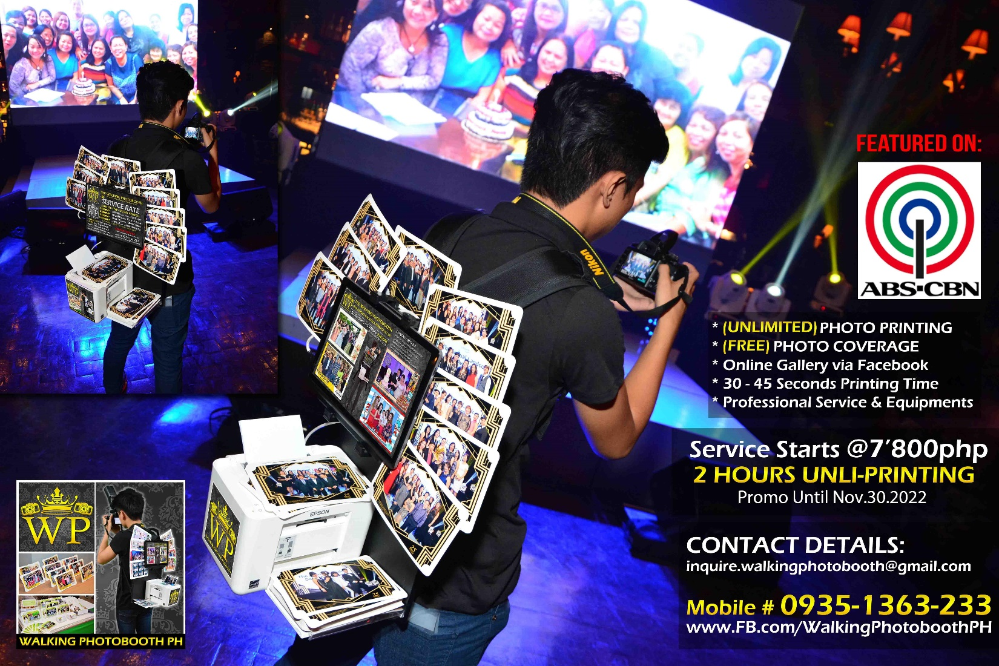

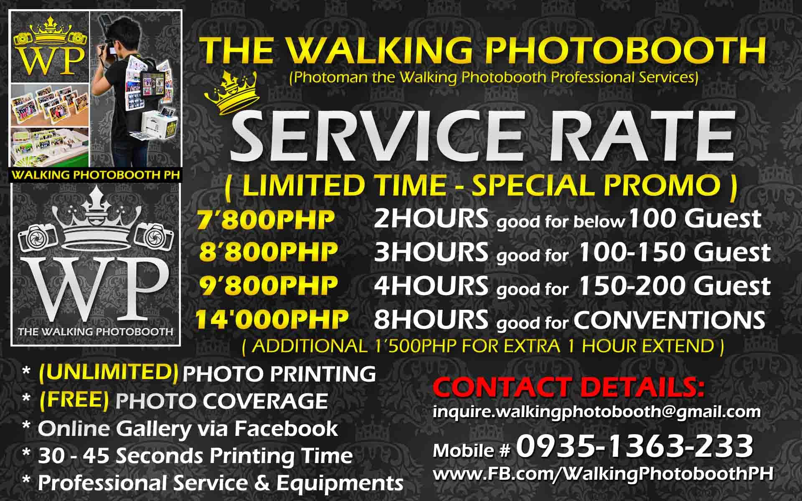

**We Also Offer Photographer and Videographer Services:**

**Photography Services**: (additional 600php per 1Hour extension)

**Whole Event Pictures** (24.1 Megapixel of RAW + JPEG Format Only)

*Whole Day Photo Coverage 8Hours 6’500php

*Half Day Photo Coverage 4Hours 4’500php

*Simple Event Photo Coverage 1-2Hours 3’500php

**Videography Services**: (additional 600php per 1Hour extension)

**Service Details** (Edited Summary AVP + Edited Music Video 3-5minutes)

*Same Day Edit Whole Day (SDE) 5-8Hours 25’000php

*Same Day Edit Reception (SDE) 3-4Hours 15’000php

*Simple Event Video Coverage 4-5Hours 8’500php

*Simple Event Video Coverage 2-3Hours 6’500php

SERVICE Transparency Breakdown

(Walking Photobooth - 2Hours Service)

Photographer Charge.…………………………1’000

Assistant Charge…………………………………….700

(This includes their transportation going to our office)

Transportation to the Event………………….350

Transportation Back…………………….……….350

(Transportation Expense via Grab Taxi)

16 GB USB……………………………………………….500

EPSON Original Cartridge Ink………….….1’350

Photo Papers and Frames……………………….850

Equipment Charge……………………………….2’400

(Rental, Maintenance for Camera Laptop & Printer etc...)

Layout Design………………………………………….300

(Payment for Layout Design for our Graphic Artist)

**Total of 7’800php** for 2 Hours Unlimited Print Service

(Succeeding hours will add on Ink and Paper Supplies)